**Home Work**

Teacher: Kiran Waghmare

Date: 01/03/2022

1. To determine a student’s final grade and indicate if he is passing or failing. The final grade is calculated as the average of 4 marks, physics, chemistry, maths and biology.

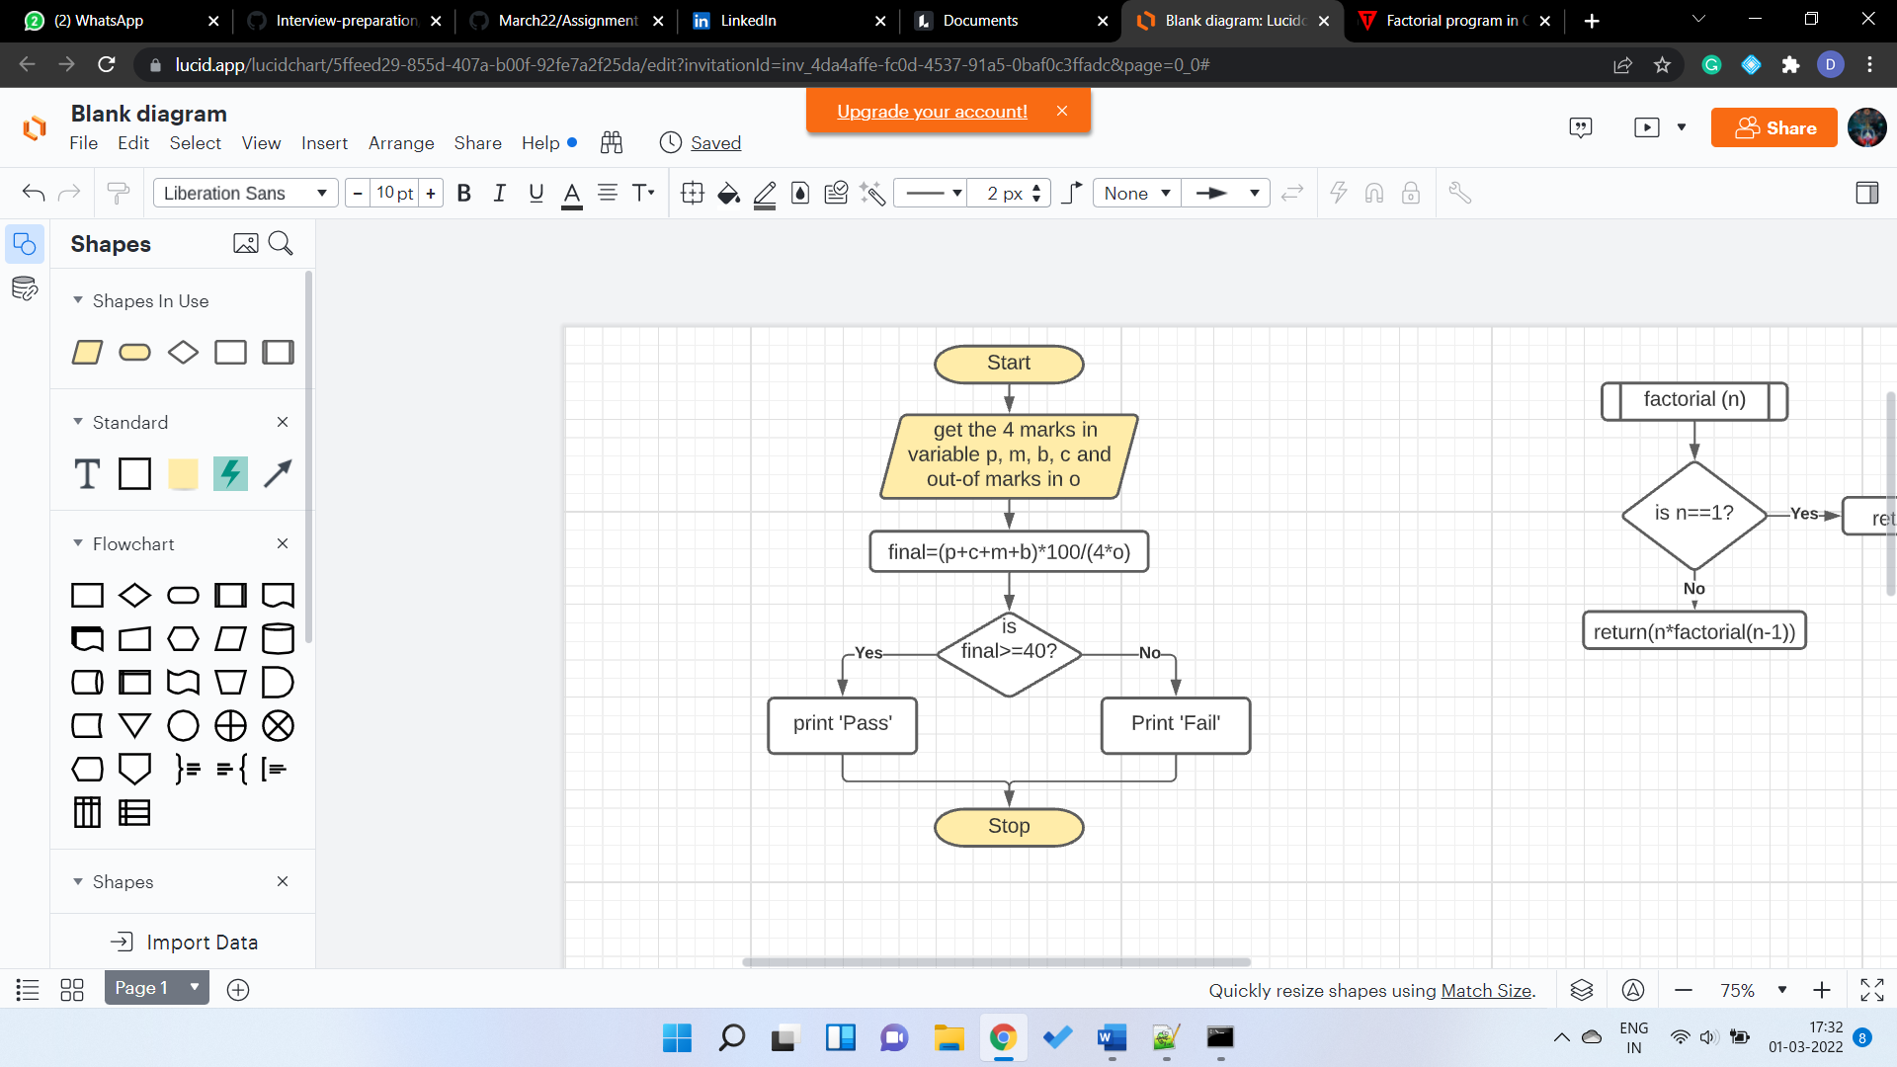

1. The flowchart for posting a letter.

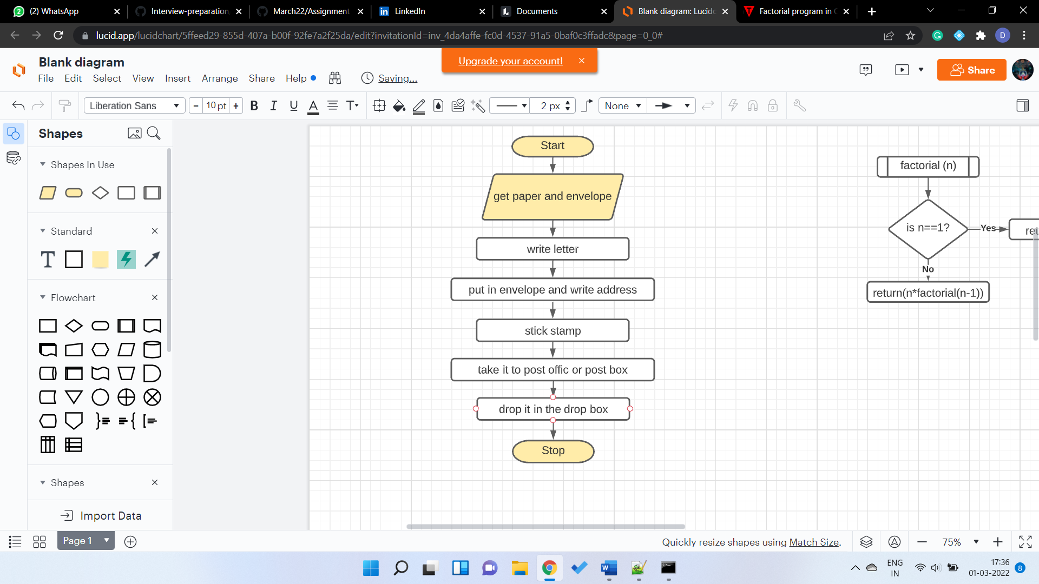

1. The flowchart to catch a school bus.

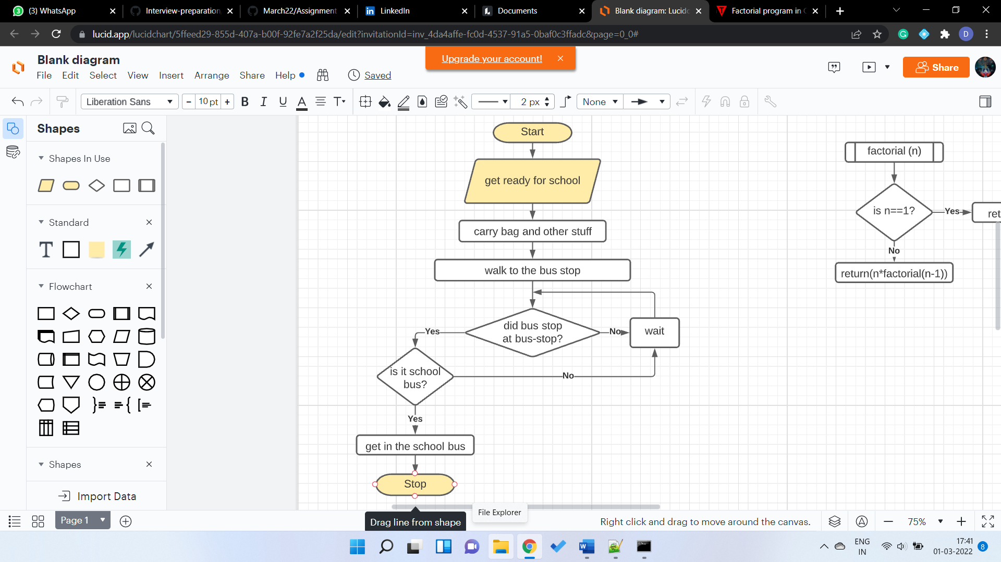

1. The flowchart for getting married.

